

International School

**Capstone Project 2**

CMU-SE 451

**Team Meeting Document**

**Craft Village Pollution Monitor System**

**Submitted by**

**Ca, Van Cong Le**

**Huy, Bui Duc**

**Phuc, Hua Hoang**

**Trung, Nguyen Thanh**

**Nhan, Huynh Ba**

**Approved by**

**Ph.D. Nguyen Thanh Binh**

**Proposal Review Panel Representative:**

Name Signature Date

**Capstone Project 2 - Mentor:**

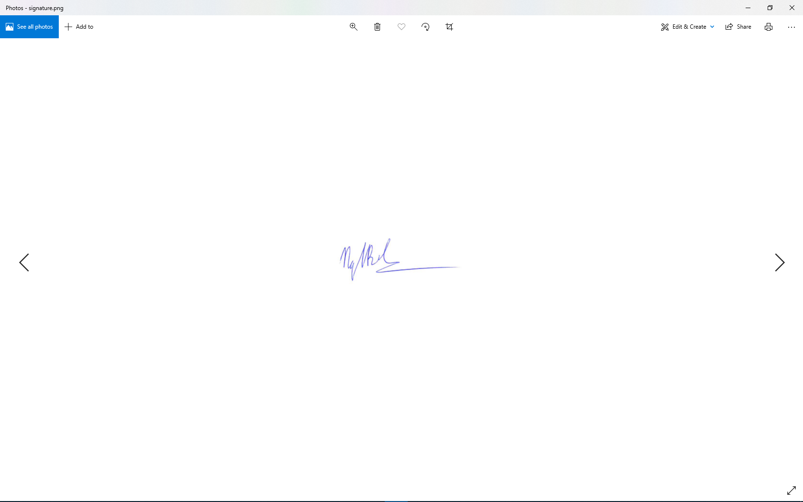

Name Signature Date

|  |  |  |  |
| --- | --- | --- | --- |
| Meeting Information | | | |
| Product | Craft Village Pollution Monitor System | | |
| Subject | Introduce, discuss topic & process | | |
| Location | Online on skype | | |
| Date and Time | *Date* | *Start Time* | *End Time* |
|  | 03/03/2023 | 21:00 | 21:30 |
| Attendees | * Van Cong Le Ca * Bui Duc Huy * Hua Hoang Phuc * Nguyen thanh Trung * Huynh Ba Nhan | | |
| Related documents | All Documents | | |
| Content | | | |
| * Confirm new requirement for capstone 2 and find solution: * Mobile application to Google Play Store. * Backend, web application and AI online via AWS or VPS. * Assign roles to new members. | | | |
| Result Items | | | |
| All Documents | | | |

|  |  |  |  |
| --- | --- | --- | --- |
| Meeting Information | | | |
| Product | Craft Village Pollution Monitor System | | |
| Subject | Report and idea clarification | | |
| Location | Online on skype | | |
| Date and Time | *Date* | *Start Time* | *End Time* |
|  | 13/03/2023 | 20:35 | 21:15 |
| Attendees | * Van Cong Le Ca * Bui Duc Huy * Hua Hoang Phuc * Nguyen thanh Trung * Huynh Ba Nhan | | |
| Related documents | Product Backlog, Architecture Document, Test Cases | | |
| Content | | | |
| * Get more project requirements: * The documentation section clearly describes the AI and Location-base workflow for members. (Ca, Huy, Phuc) * Consider whether a solution using AWS is appropriate. * Check for errors detected during use on real devices. * Implement new functional code for web application. | | | |
| Result Items | | | |
| * Required documents: * Product Backlog * Architecture Document * Test Cases | | | |

|  |  |  |  |
| --- | --- | --- | --- |
| Meeting Information | | | |
| Product | Craft Village Pollution Monitor System | | |
| Subject | Report and idea clarification | | |
| Location | Online on skype | | |
| Date and Time | *Date* | *Start Time* | *End Time* |
|  | 22/03/2023 | 20:45 | 21:30 |
| Attendees | * Van Cong Le Ca * Bui Duc Huy * Hua Hoang Phuc * Nguyen thanh Trung * Huynh Ba Nhan | | |
| Related documents | Product Backlog, Architecture Document, Test Cases | | |
| Content | | | |
| * More specific analysis of AI and Location-Based Workflows discussed with previous teachers. * Research the free version of AWS and look at paid options. * Check the detected errors on the system after running online. | | | |
| Result Items | | | |
| * Required documents: * Product Backlog * Architecture Document * Test Cases | | | |

|  |  |  |  |
| --- | --- | --- | --- |
| Meeting Information | | | |
| Product | Craft Village Pollution Monitor System | | |
| Subject | Report and idea clarification | | |
| Location | Online on Facebook | | |
| Date and Time | *Date* | *Start Time* | *End Time* |
|  | 28/03/2023 | 20:00 | 20:50 |
| Attendees | * Van Cong Le Ca * Bui Duc Huy * Hua Hoang Phuc * Nguyen thanh Trung * Huynh Ba Nhan | | |
| Related documents | Product Backlog, Architecture Document, Test Cases | | |
| Content | | | |
| * Declare the functions that have been - are - will do. (Summarize words for teachers). * Report bugs using trello. * Server rental: * Use temporary free version. * The next time you meet, you will ask if you need a paid copy. * Fixed group meeting schedule: * The format of the meeting will be to meet the teacher and then have a group meeting. * Fixed at 20:30 every Thursday. (There will be additional group meetings during the week or change meetings if necessary) * Next Thursday: The Backend team will report to you on the work done and have related questions. | | | |
| Result Items | | | |
| * Required documents: * Product Backlog * Architecture Document * Test Cases | | | |

|  |  |  |  |
| --- | --- | --- | --- |
| Meeting Information | | | |
| Product | Craft Village Pollution Monitor System | | |
| Subject | Report and idea clarification | | |
| Location | Online on skype | | |
| Date and Time | *Date* | *Start Time* | *End Time* |
|  | 30/03/2023 | 20:35 | 21:15 |
| Attendees | * Van Cong Le Ca * Bui Duc Huy * Hua Hoang Phuc * Nguyen thanh Trung * Huynh Ba Nhan | | |
| Related documents | Product Backlog, Architecture Document, Test Cases | | |
| Content | | | |
| * More specific analysis of AI and Location-Based Workflows discussed with previous teachers. * Take into account the option of renting VPS. * Check the detected errors on the system. | | | |
| Result Items | | | |
| * Required documents: * Product Backlog * Architecture Document * Test Cases | | | |

|  |  |  |  |
| --- | --- | --- | --- |
| Meeting Information | | | |
| Product | Craft Village Pollution Monitor System | | |
| Subject | Report, demo and idea clarification | | |
| Location | Online on skype | | |
| Date and Time | *Date* | *Start Time* | *End Time* |
|  | 06/04/2023 | 22:00 | 23:00 |
| Attendees | * Van Cong Le Ca * Bui Duc Huy * Hua Hoang Phuc * Nguyen thanh Trung * Huynh Ba Nhan | | |
| Related documents | Product Backlog, Architecture Document, Test Cases | | |
| Content | | | |
| * Re-deploy the notice of the faculty meeting for those who could not attend that afternoon. * Clarifying AI and location-based workflows. * Notice about renting VPS server and guide other teams to change IP for the application. * Review bugs | | | |
| Result Items | | | |
| * Required documents: * Product Backlog * Architecture Document * Test Cases | | | |

|  |  |  |  |
| --- | --- | --- | --- |
| Meeting Information | | | |
| Product | Craft Village Pollution Monitor System | | |
| Subject | Report and idea clarification | | |
| Location | Online on Facebook | | |
| Date and Time | *Date* | *Start Time* | *End Time* |
|  | 11/04/2023 | 20:00 | 20:30 |
| Attendees | * Van Cong Le Ca * Bui Duc Huy * Hua Hoang Phuc * Nguyen thanh Trung * Huynh Ba Nhan | | |
| Related documents | Product Backlog, Architecture Document, Test Cases | | |
| Content | | | |
| * Teams announce the functions that have been - are - will do. * Divide and update related documents. * Review bugs | | | |
| Result Items | | | |
| All Documents | | | |

|  |  |  |  |
| --- | --- | --- | --- |
| Meeting Information | | | |
| Product | Craft Village Pollution Monitor System | | |
| Subject | Report, demo and idea clarification | | |
| Location | Online on skype | | |
| Date and Time | *Date* | *Start Time* | *End Time* |
|  | 13/04/2023 | 21:10 | 22:20 |
| Attendees | * Van Cong Le Ca * Bui Duc Huy * Hua Hoang Phuc * Nguyen thanh Trung * Huynh Ba Nhan | | |
| Related documents | Product Backlog, Architecture Document, Test Cases | | |
| Content | | | |
| * Clarifying AI and location-based workflows: * When making decisions, AI needs to synthesize information from craft villages and photos to be able to make the most accurate decisions. * Unify how to generate/Data to train AI. * Agree on the mobile application that will extract data from the image. | | | |
| Result Items | | | |
| * Required documents: * Product Backlog * Architecture Document * Test Cases | | | |

|  |  |  |  |
| --- | --- | --- | --- |
| Meeting Information | | | |
| Product | Craft Village Pollution Monitor System | | |
| Subject | Report and idea clarification | | |
| Location | Online on Facebook | | |
| Date and Time | *Date* | *Start Time* | *End Time* |
|  | 15/04/2023 | 19:00 | 21:00 |
| Attendees | * Van Cong Le Ca * Bui Duc Huy * Hua Hoang Phuc * Nguyen thanh Trung * Huynh Ba Nhan | | |
| Related documents | Product Backlog, Architecture Document, Test Cases | | |
| Content | | | |
| * Teams announce the functions that have been - are - will do. * Divide and update related documents. * AI team presents AI training plan. * Agree on the plan to get/create data for AI. * Review bugs | | | |
| Result Items | | | |
| * Required documents: * Product Backlog * Architecture Document * Test Cases | | | |

|  |  |  |  |
| --- | --- | --- | --- |
| Meeting Information | | | |
| Product | Craft Village Pollution Monitor System | | |
| Subject | Report and idea clarification | | |
| Location | Online on Facebook | | |
| Date and Time | *Date* | *Start Time* | *End Time* |
|  | 18/04/2023 | 20:00 | 20:30 |
| Attendees | * Van Cong Le Ca * Bui Duc Huy * Hua Hoang Phuc * Nguyen thanh Trung * Huynh Ba Nhan | | |
| Related documents | Product Backlog, Architecture Document, Test Cases | | |
| Content | | | |
| * Teams announce the functions that have been - are - will do. * Divide and update related documents. * AI team presents AI training plan. * Review bugs | | | |
| Result Items | | | |
| * Required documents: * Product Backlog * Architecture Document * Test Cases | | | |

|  |  |  |  |
| --- | --- | --- | --- |
| Meeting Information | | | |
| Product | Craft Village Pollution Monitor System | | |
| Subject | Report and idea clarification | | |
| Location | Online on skype | | |
| Date and Time | *Date* | *Start Time* | *End Time* |
|  | 20/04/2023 | 21:30 | 22:30 |
| Attendees | * Van Cong Le Ca * Bui Duc Huy * Hua Hoang Phuc * Nguyen thanh Trung * Huynh Ba Nhan | | |
| Related documents | Product Backlog, Architecture Document, Test Cases | | |
| Content | | | |
| * Teams announce the functions that have been - are - will do. * Divide and update related documents. * Update the progress of data creation and division of new tasks for the whole team. * Review bugs | | | |
| Result Items | | | |
| * Required documents: * Product Backlog * Architecture Document * Test Cases | | | |

|  |  |  |  |
| --- | --- | --- | --- |
| Meeting Information | | | |
| Product | Craft Village Pollution Monitor System | | |
| Subject | Report and idea clarification | | |
| Location | Online on Facebook | | |
| Date and Time | *Date* | *Start Time* | *End Time* |
|  | 22/04/2023 | 16:00 | 16:30 |
| Attendees | * Van Cong Le Ca * Bui Duc Huy * Hua Hoang Phuc * Nguyen thanh Trung * Huynh Ba Nhan | | |
| Related documents | Product Backlog, Architecture Document, Test Cases | | |
| Content | | | |
| * Teams announce the functions that have been - are - will do. * Divide and update related documents. * Update the progress of data creation and division of new tasks for the whole team. * Review bugs * Prepare for the midterm review: * Documents * Source code * Laptop * Mobile Phone * Time and place of meeting | | | |
| Result Items | | | |
| All Documents | | | |

|  |  |  |  |
| --- | --- | --- | --- |
| Meeting Information | | | |
| Product | Craft Village Pollution Monitor System | | |
| Subject | Report and idea clarification | | |
| Location | Online on Facebook | | |
| Date and Time | *Date* | *Start Time* | *End Time* |
|  | 25/04/2023 | 20:00 | 20:30 |
| Attendees | * Van Cong Le Ca * Bui Duc Huy * Hua Hoang Phuc * Nguyen thanh Trung * Huynh Ba Nhan | | |
| Related documents | Product Backlog, Architecture Document, Test Plan, Test Cases | | |
| Content | | | |
| * Teams announce the functions that have been - are - will do. * Divide and update related documents. * Update the progress of data creation and division of new tasks for the whole team. * Review bugs * Deploy and re-evaluate the bad contents in the mid-term review: * Product backlog documentation * Test plan documentation. * Documentation of test cases. | | | |
| Result Items | | | |
| * Required documents: * Product Backlog * Architecture Document * Test Plan * Test Cases | | | |

|  |  |  |  |
| --- | --- | --- | --- |
| Meeting Information | | | |
| Product | Craft Village Pollution Monitor System | | |
| Subject | Report and idea clarification | | |
| Location | Online on Facebook | | |
| Date and Time | *Date* | *Start Time* | *End Time* |
|  | 03/05/2023 | 13:00 | 13:30 |
| Attendees | * Van Cong Le Ca * Bui Duc Huy * Hua Hoang Phuc * Nguyen thanh Trung * Huynh Ba Nhan | | |
| Related documents | Product Backlog, Architecture Document, Test Cases | | |
| Content | | | |
| * Teams announce the functions that have been - are - will do. * Divide and update related documents. * Review bugs * Algorithm update and workflow reassessment for AI and LSB. | | | |
| Result Items | | | |
| * Required documents: * Product Backlog * Architecture Document * Test Cases | | | |

|  |  |  |  |
| --- | --- | --- | --- |
| Meeting Information | | | |
| Product | Craft Village Pollution Monitor System | | |
| Subject | Report | | |
| Location | Online on Facebook | | |
| Date and Time | *Date* | *Start Time* | *End Time* |
|  | 04/05/2023 | 21:15 | 22:00 |
| Attendees | * Van Cong Le Ca * Bui Duc Huy * Hua Hoang Phuc * Nguyen thanh Trung * Huynh Ba Nhan | | |
| Related documents | Product Backlog, Architecture Document, Test Cases | | |
| Content | | | |
| * Teams announce the functions that have been - are - will do. * Divide and update related documents. * Review bugs * Updated datasets for AI training and data processing. | | | |
| Result Items | | | |
| * Required documents: * Product Backlog * Architecture Document * Test Cases | | | |

|  |  |  |  |
| --- | --- | --- | --- |
| Meeting Information | | | |
| Product | Craft Village Pollution Monitor System | | |
| Subject | Report | | |
| Location | Online on Facebook | | |
| Date and Time | *Date* | *Start Time* | *End Time* |
|  | 06/05/2023 | 19:00 | 19:30 |
| Attendees | * Van Cong Le Ca * Bui Duc Huy * Hua Hoang Phuc * Nguyen thanh Trung * Huynh Ba Nhan | | |
| Related documents | Product Backlog, Architecture Document, Test Cases | | |
| Content | | | |
| * Teams announce the functions that have been - are - will do. * Divide and update related documents. * Review bugs. | | | |
| Result Items | | | |
| * Required documents: * Product Backlog * Architecture Document * Test Cases | | | |

|  |  |  |  |
| --- | --- | --- | --- |
| Meeting Information | | | |
| Product | Craft Village Pollution Monitor System | | |
| Subject | Report | | |
| Location | Online on skype | | |
| Date and Time | *Date* | *Start Time* | *End Time* |
|  | 08/05/2023 | 21:00 | 22:15 |
| Attendees | * Van Cong Le Ca * Bui Duc Huy * Hua Hoang Phuc * Nguyen thanh Trung * Huynh Ba Nhan | | |
| Related documents | Product Backlog, Architecture Document, Test Cases | | |
| Content | | | |
| * Teams announce the functions that have been - are - will do. * Divide and update related documents. * Review bugs. | | | |
| Result Items | | | |
| * Required documents: * Product Backlog * Architecture Document * Test Cases | | | |

|  |  |  |  |
| --- | --- | --- | --- |
| Meeting Information | | | |
| Product | Craft Village Pollution Monitor System | | |
| Subject | Report | | |
| Location | Online on Facebook | | |
| Date and Time | *Date* | *Start Time* | *End Time* |
|  | 10/05/2023 | 19:00 | 19:30 |
| Attendees | * Van Cong Le Ca * Bui Duc Huy * Hua Hoang Phuc * Nguyen thanh Trung * Huynh Ba Nhan | | |
| Related documents | All Documents | | |
| Content | | | |
| * Teams announce the functions that have been - are - will do. * Divide and update related documents. * Review bugs. | | | |
| Result Items | | | |
| All Documents | | | |

|  |  |  |  |
| --- | --- | --- | --- |
| Meeting Information | | | |
| Product | Craft Village Pollution Monitor System | | |
| Subject | Report | | |
| Location | Online on Facebook | | |
| Date and Time | *Date* | *Start Time* | *End Time* |
|  | 12/05/2023 | 19:00 | 19:30 |
| Attendees | * Van Cong Le Ca * Bui Duc Huy * Hua Hoang Phuc * Nguyen thanh Trung * Huynh Ba Nhan | | |
| Related documents | All Documents | | |
| Content | | | |
| * Teams announce the functions that have been - are - will do. * Divide and update related documents. * Review bugs. | | | |
| Result Items | | | |
| All Documents | | | |

|  |  |  |  |
| --- | --- | --- | --- |
| Meeting Information | | | |
| Product | Craft Village Pollution Monitor System | | |
| Subject | Emergency meeting | | |
| Location | Online on skype | | |
| Date and Time | *Date* | *Start Time* | *End Time* |
|  | 15/05/2023 | 20:50 | 21:40 |
| Attendees | * Van Cong Le Ca * Bui Duc Huy * Hua Hoang Phuc * Nguyen thanh Trung * Huynh Ba Nhan | | |
| Related documents | All Documents | | |
| Content | | | |
| * Teams announce the functions that have been - are - will do. * Divide and update related documents. * Handle conflict survey with household. * Review bugs. | | | |
| Result Items | | | |
| All Documents | | | |